**DIGITAL MARKETING PROJECT**

**Brand name :** Dreamland home renovation

**Team ID:** NM2023TMID02174

**EMAIL ID:** [Dreamlandhomerenovation@gmail.com](mailto:Dreamlandhomerenovation@gmail.com)

**BLOGGER ID:** [**https://dreamlandinhome.blogspot.com/**](https://dreamlandinhome.blogspot.com/)

**PROJECT TITLE :** PPC-AD-GOOGLE-ADS

**Logo:**

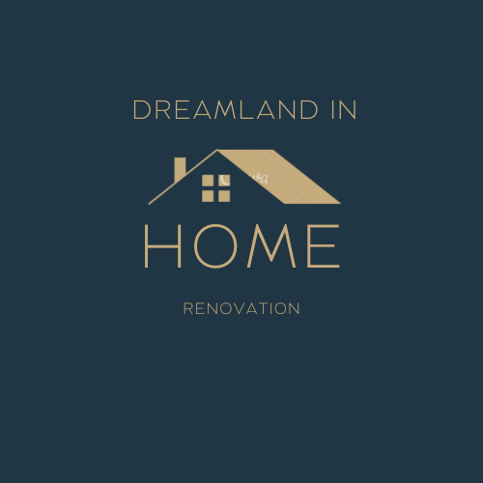

**DESCRIPTION:**

Home renovation, also known as home remodeling or home improvement, is the process of making significant changes or updates to an existing residential property to enhance its functionality, aesthetics, and overall value. Homeowners often embark on renovation projects to accommodate changing needs, increase energy efficiency, or simply to give their home a fresh and modern look.

**Planning and Budgeting:**

Design and Architectural Plans: Creating detailed blueprints or design concepts that outline the

**TEAM MEMBERS DETAILS:**

|  |  |
| --- | --- |
| **TEAM MEMBERS** | **TEAM ID** |
| G. PUNITHA SOPHIYA MARY (TL) | 4E4345DA5E87DC6998C4D929EEA64EAC |
| K.RENUGA | VE6703F932EEIF5BFA94757E9F5CB0AC |
| S.SAKTHI SRI | F4C7FDCA382635A903F446E17EB85BAA |
| M.UDHAYAHARINI | BDBCED8319B7BD091F94EFF4E6D757C4 |

**Step 1:** First we go to the link ,which is given in the NM-portal https://www.google.com/search?q=google+ads&rlz=1CIONGR_enl



**Step 2:** Click the start now space



**Step 3:** Choose an email account which is created for your business page

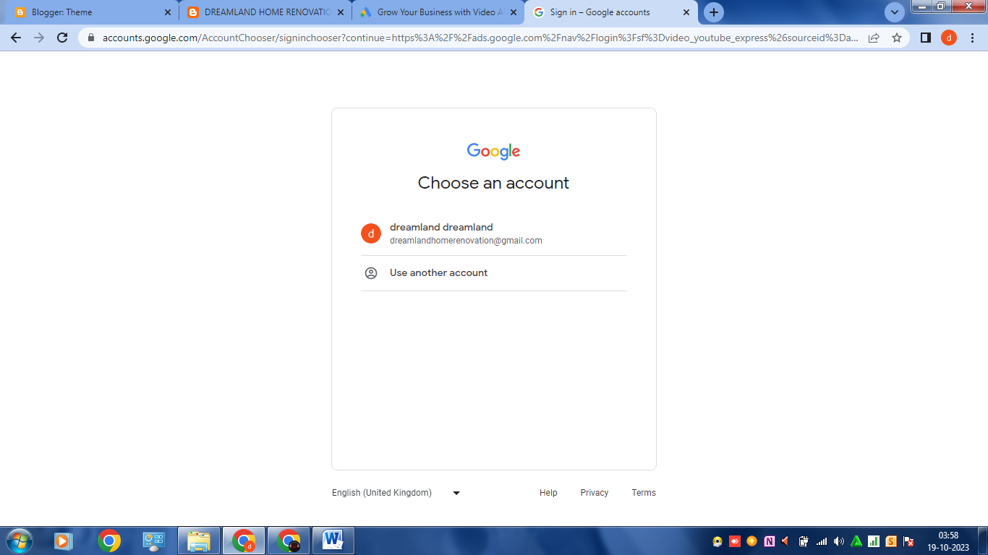

**Step 4:** Go to new campaign and choose campaign objectives:

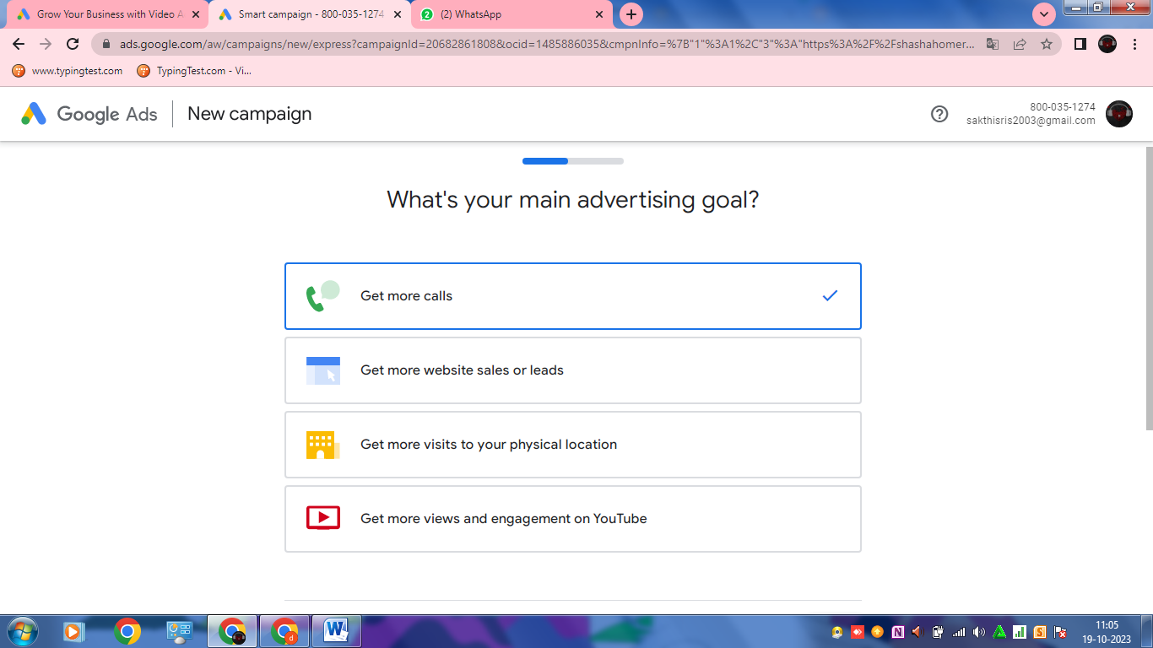

**Step 5:** Enter the website and campaign name:

Website: <https://dreamlandinhome.blogspot.com/>

Campaign name: DREAMLAND IN HOME RENOVATION

**Step 6:** select a location and language:

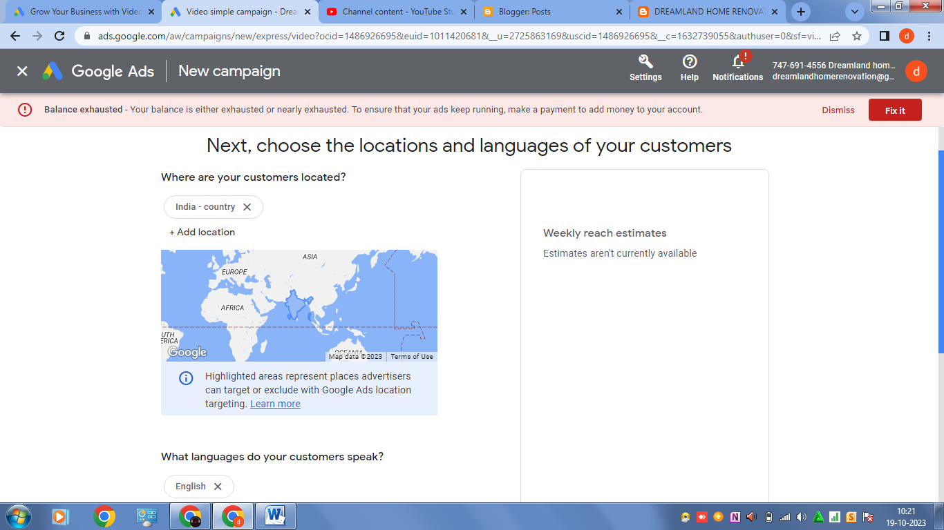

**Step 7:** Ad schedule and duration :

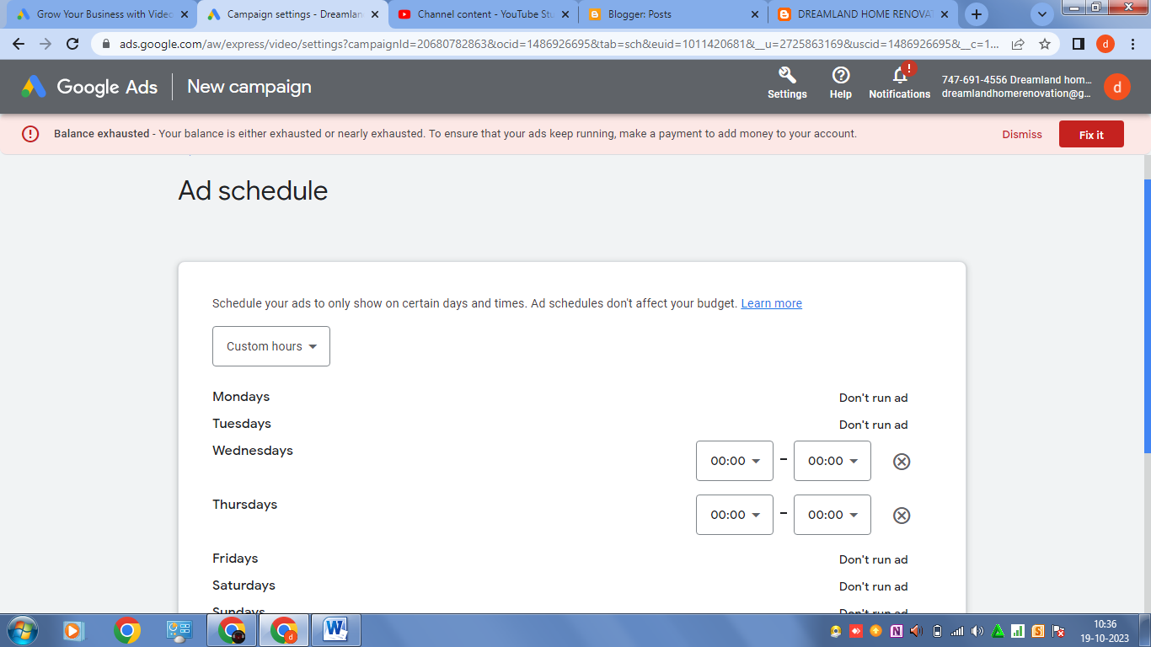

**STEP 8:** Ad budjet:

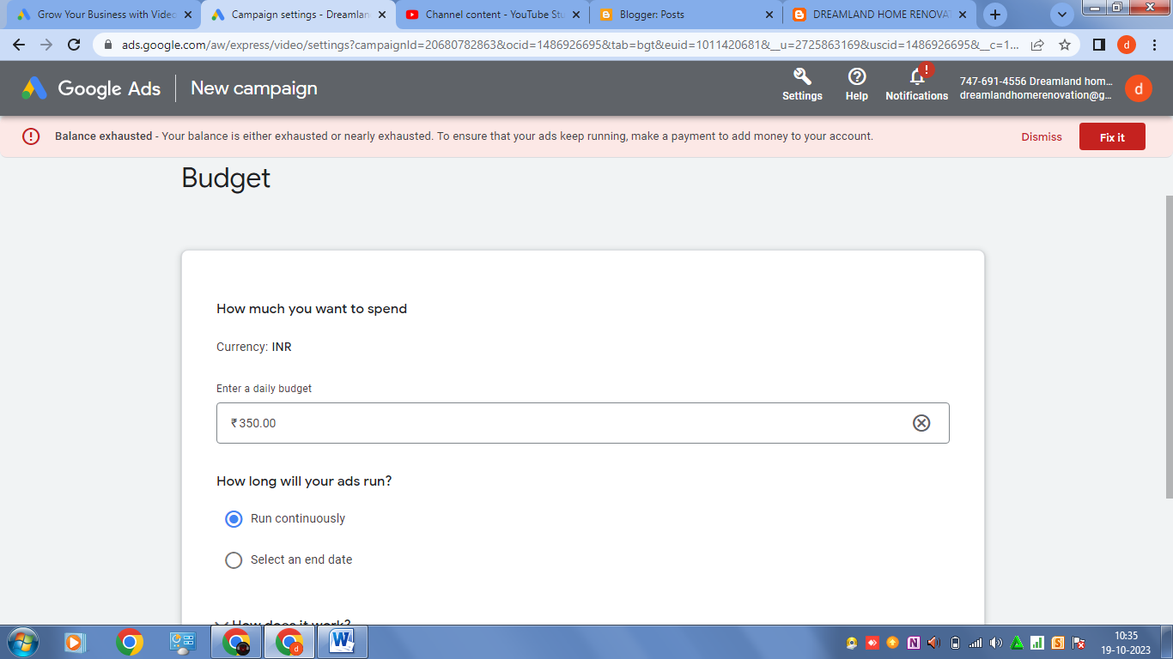

**Step 9:** Demographics:

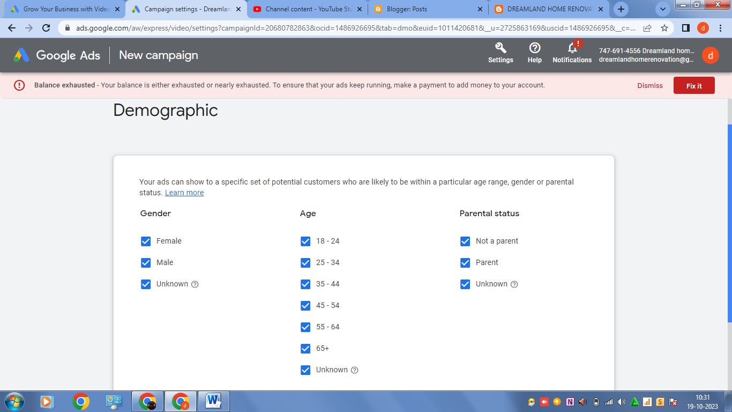

**Step 10** : keywords and topics:

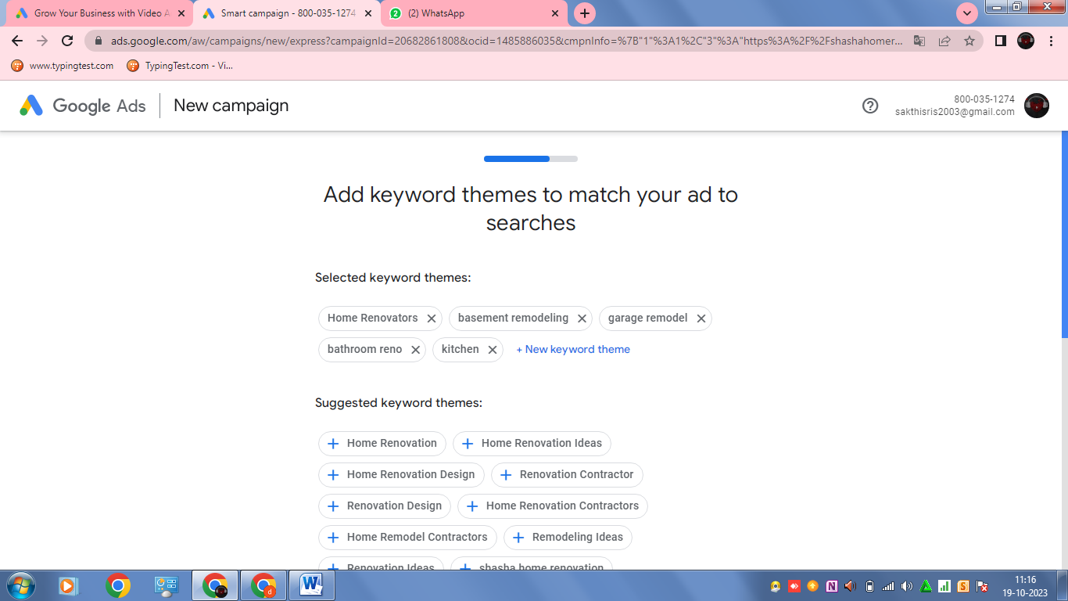

**Step 11:** Upload video:

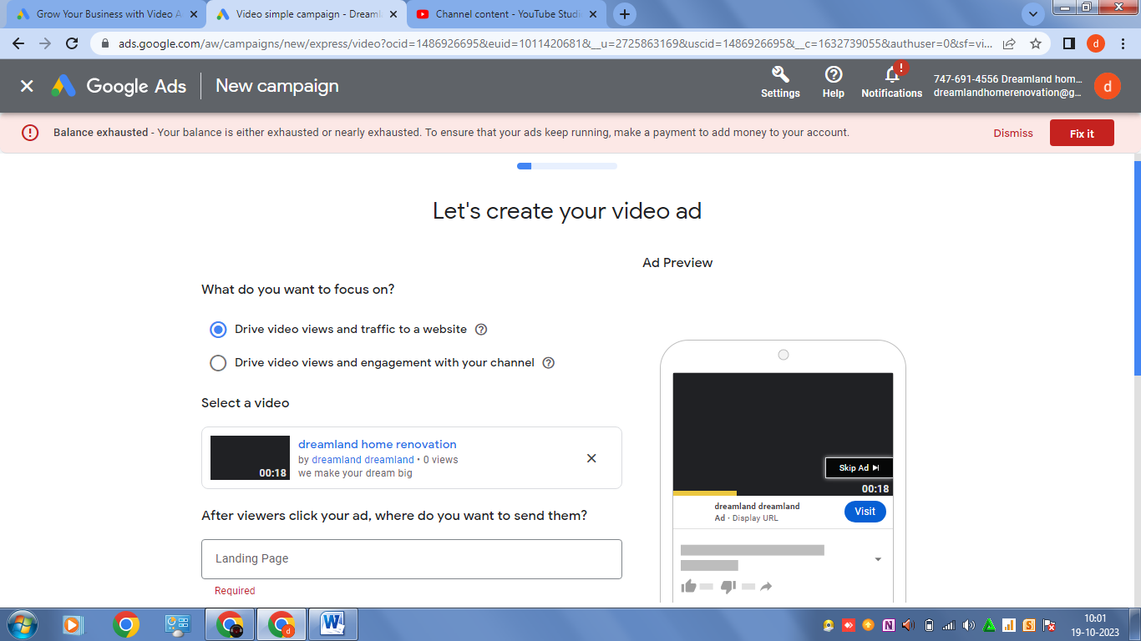

Video link: <https://youtu.be/1AVR9R1qTiY>

**Step 12:** Headlines and description

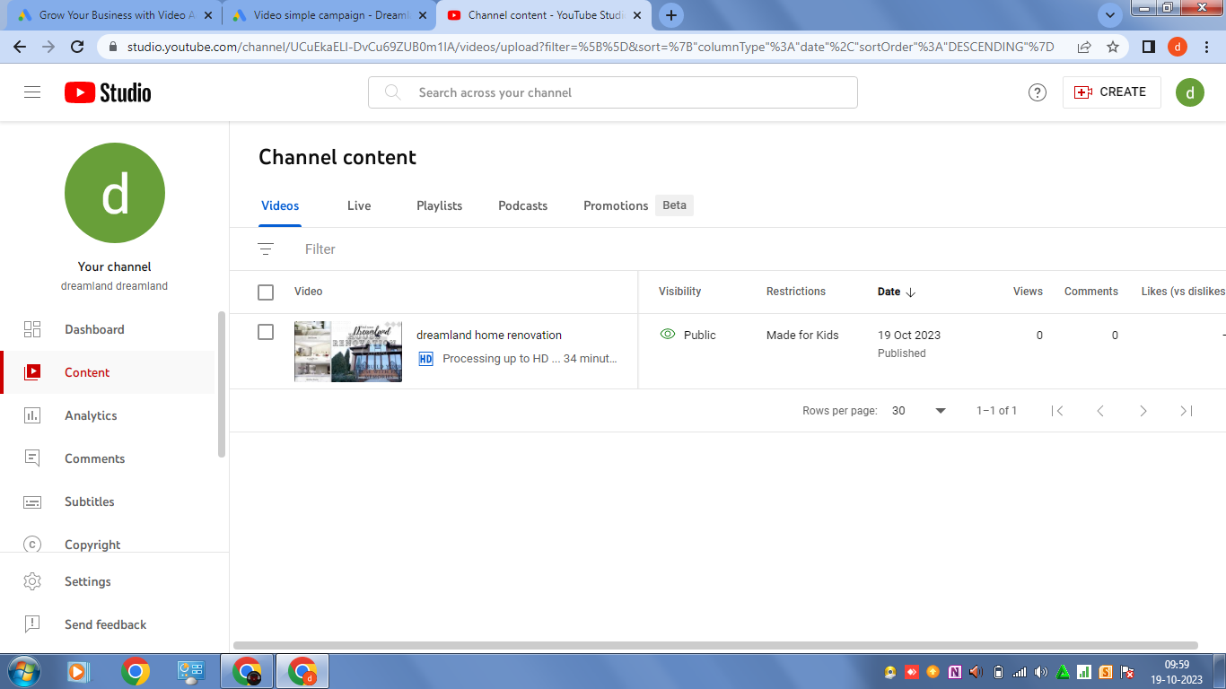

**Step 13:** publish and preview of google ads

